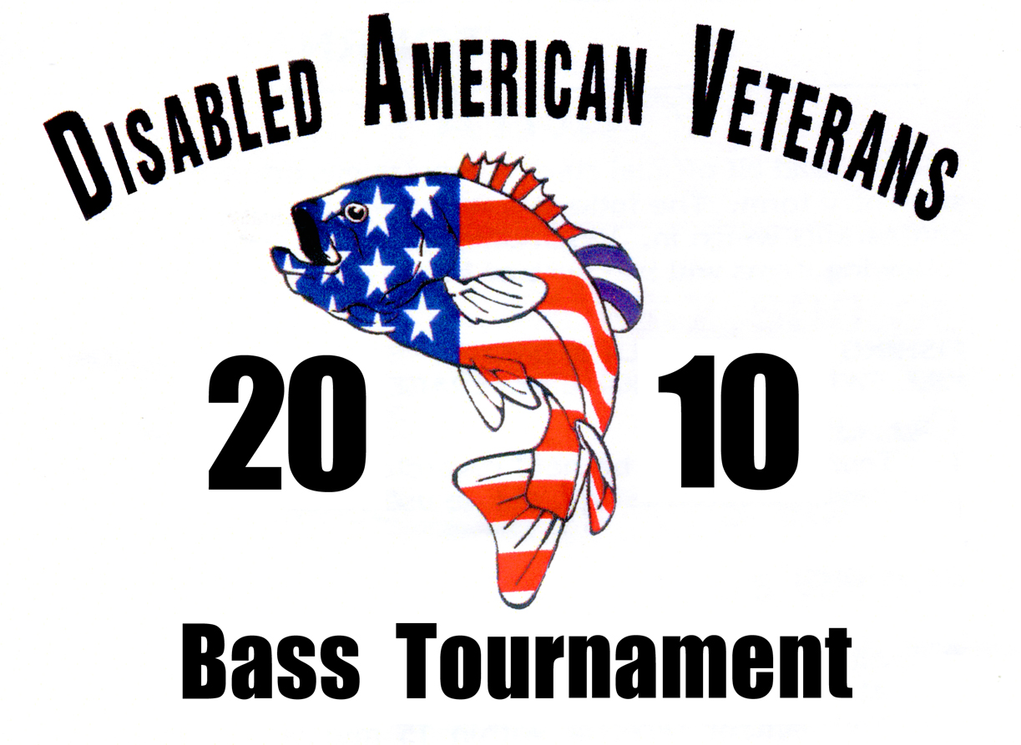
APRIL 3, 2010
LAKE DARDANELLE STATE PARK
Russellville, Arkansas

ENTRY FORM

Name: _______________________________________________________________
Please print
Address: ____________________________________________e-mail___________________

City: ___________________________State:____ Zip: _______Phone # (____)____________

Signature: ____________________________________________________________

Partner’s Name: ________________________________________________________
Please print
Address: _______________________________________e-mail _________________

City: _____________________ State: ____Zip: _______ Phone #(___)_________________

Signature: ____________________________________________________________

By signing this application, I am releasing the tournament and the Disabled American Veterans from all liability and injuries incurred during this event. I have read the tournament rules and regulations, and understand by violating them I will be disqualified from the tournament.

Entry Fee per BOAT: ………………….. $100.00 (1 OR 2 PEOPLE)

Make check payable to: DAV 2010 Bass Tournament
P. O. Box 1620
North Little Rock, AR 72115
Inquires: 501-257-1896 Website: www.davoutdoors.com

