Department of Arkansas


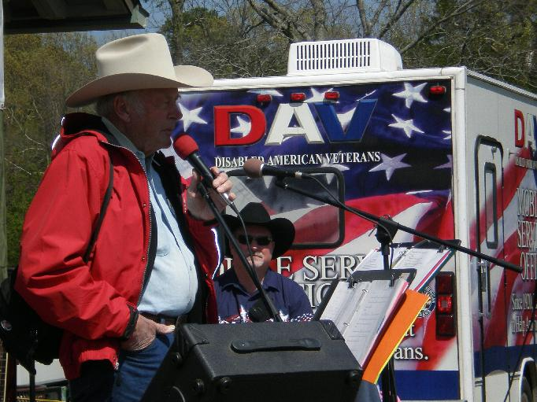
(Forrest Wood at 2008’s weigh-in)
We are in hopes he will be here in April

APRIL 3, 2010
LAKE DARDANELLE STATE PARK
RUSSELLVILLE, ARKANSAS

$$$100.00 ENTRY FEE PER BOAT
$4,800.00 IN TOTAL PRIZE MONEY
PAYOUT TO TOP 20 TEAMS + 2 “BIG BASS” PAYOUTS

VISIT OUR WEBSITE www.davoutdoors.com FOR A TOURNAMENT APPLICATION AND RULES --- OR CALL (501) 257-1896 FOR MORE INFORMATION.

THIS IS A CHARITY EVENT TO HELP OUR VETERANS!!!
This tournament helps fund D.A.V. Transportation Network’s free rides for Veterans and other projects. The D.A.V. transports nearly 25,000 Veterans, over 600,000 miles safe and at no cost to the Veteran. We have over 200 Volunteer drivers across the state that has volunteered over 30,000 hours last year. The D.A.V. Department of Arkansas is a 501 (c) 3 non-profit organization. © 2007 Disabled American Veterans, Department of Arkansas, Inc.

