Disabled American Veterans
Department of Arkansas
Post Office Box 1620
North Little Rock, AR 72115

Address Correction Required

MAJOR SPONSORS
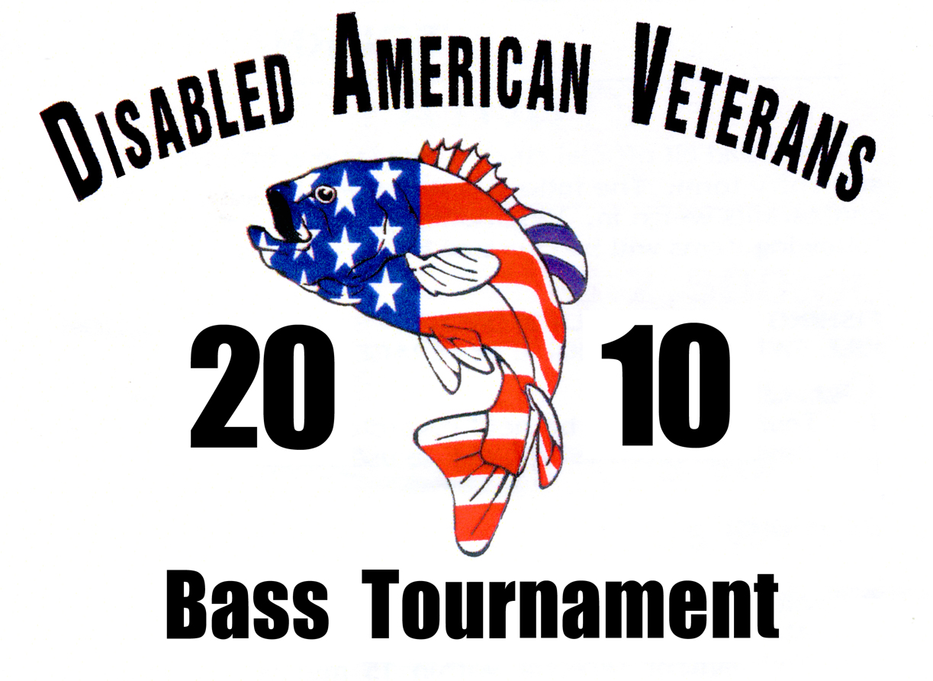

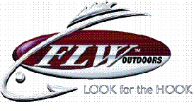


APRIL 3, 2010

Lake Dardanelle
State Park
Russellville, Arkansas

SPONSOR’S APPLICATION

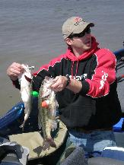

Web site: www.davoutdoors.com
Phone: 501-257-1896
Forrest Wood at
DAV Bass Tournament Weigh-In

THIS IS A CHARITY TOURNAMENT

ALL FISHERMEN WELCOME

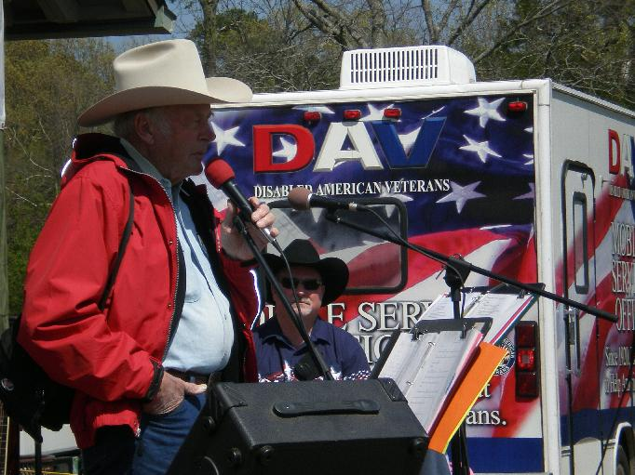

DISABLED AMERICAN VETERANS
“BIG BASS SPONSORS”
DONATION . . . . . $500.
11:00 a.m. “Big Bass” Golden Corral (taken)
3:00 p.m. “Big Bass” Ranger Boats (taken)
OTHER TIMES ARE AVAILABLE!
- Weigh-In Hour named after company
- Weigh in Stage & Entry Banner with your Company’s Name & Recognition at 2010 Convention & Booklet
- ”DAV” Tournament Plaque
“MEDAL OF HONOR” SPONSORS
DONATION . . . . . $450.
- Entry Banner* Weigh-In Banner with Company Name
- Promoted in all press and media releases
- Recognition at 2010 DAV Department Convention + Booklet
- “DAV” Tournament Plaque
“PURPLE HEART” SPONSORS
DONATION . . . . . $350.
- Entry Banner with Company Name
- Weigh-In Stage Banner with Company Name
- Recognition at 2010 DAV Department Convention + Booklet
“VICTORY MEDAL” SPONSORS
- “DAV” Tournament Plaque
- Entry Banner with Company Name
DONATION . . . . . $250.
“TRANSPORTATION NETWORK” SPONSORs
DONATION . . . . . $150.
- Entry Banner with Company Name

SIGN-UP FORM

Sign up for:

______________________ $___________
(Name of sponsorship) (Amount)

Company __________________________________

Contact Person ____________________________

Address: __________________________________

City________________________________________

Phone _____________________________________

E-mail ____________________________________

Method of Payment:

❒ Credit Card (call office to charge)
❒ Check
❒ Bill me

WE NEED SPONSORS!
DEPARTMENT OF ARKANSAS
PROGRAMS AND PROJECTS

The DAV Department of Arkansas is a 501[C] (4) nonprofit veterans’ service organization with one single purpose “Building Better Lives for Arkansas’ disabled veterans”.
Transports veterans to VA Medical Center medical appointments free-of-charge using DAV volunteers and vans purchased by the DAV. The Department of Arkansas transported over 15,000 veterans over 600,000 miles last year.
Offers free professional representation to veterans and their families before the Department of Veterans Affairs.
Free counseling assistance to active duty and National Guard personnel transitioning in to civilian life.
Work with State and Federal Legislators to protect and defend the rights of veterans and their families. Chartered by Congress to be the official voice of the disabled veteran.
Supply patriotic materials to schools to promote patriotism, flag ethics and educate on disabilities.
Annual activities for VA hospitalized veterans.
We are currently updating our website but for information regarding DAV, visit www.ardav.org and information on our bass tournament at www.davoutdoors.com

Disabled American Veterans
Department of Arkansas
P O Box 1620
North Little Rock, AR 72115

Phone: 501-257-1896
Fax: 501-257-1897
www.davoutdoors.com

